**Fixture Offsets**

Fixture offsets are complicated, there is no way around it. The following describes how offsets are organized in the Chip application which can handle multiple mounts on one fixture. Every effort has been made to make offsets as simple as possible.

Offsets are a way of positioning the GCode program. GCode programs typically have an origin based on the CAD drawing they were derived from, usually the lower left corner.

As an example take a simple 1 inch by 1 inch square part that is to have some machining on the top surface, like two holes drilled in it.

(1,1)

(0,0)

The CAD drawing has the bottom left corner at coordinates (0, 0) and the upper left corner at (1, 1). After running the drawing through a CAM session the GCode file will reflect these coordinates.

When mounting the part on a fixture, the lower left corner (or 0, 0) will not be at the machines origin (0, 0). Offsets are used to reorient the GCode program to the proper place.

The fixture shown below has mounts for two parts. Each mount has two locating pins (shown in orange). The parts are registered against these locating pins clamps hold them in place (clamps shown in green).

(2, 4) (8, 4)

Y (2, 3) (7, 3)

X

(2, 4) (8, 4)

Y (2, 3) (7, 3)

X

To position the GCode program, the Chip application uses two sets of coordinates, Mount Offsets and Part Offsets. The Mount offsets for the left hand part is (2, 4), the right (8, 4). The Part Offsets for both parts are based on the width (1”) and length (1”) of the part, and the orientation to the locator pins (explained below). Both of these coordinates can be specified in the Chip application in the data that describe the offsets.

Let’s examine each part one at a time. When the left hand part is mounted, the upper left corner is at (2, 4). Where 2 is the X axis and 4 is the Y axis. That means that the bottom left corner is at (2, 3) ie. X = 2, Y = 3, so the GCode program should be oriented at (2, 3). The calculations are as follows.

X Offset = Mount Offset X + Part Offset X where Mount Offset X = 2, Part Offset X = 0

X Offset = 2 + 0 = 2

Y Offset = Mount Offset Y + Part Offset Y where Mount Offset Y = 4, Part Offset Y = -1

Y Offset = 4 + (-1) = 3

The reason the Part Offset X is zero is because the part is mounted to its left side, so there is no offsetting necessary, but in the Y direction, the part is mounted to the top side, which is opposite from the GCode origin.

See next page for another example.

Now let’s look at the right hand part.

(2, 4) (8, 4)

Y (2, 3) (7, 3)

X

When the right hand part is mounted the upper right corner is at (8, 4), so the lower left corner is at (7, 3).

X Offset = Mount Offset X + Part Offset X where Mount Offset X = 8, Part Offset X = -1

Y Offset = Mount Offset Y + Part Offset Y where Mount Offset Y = 4, Part Offset Y = -1

X Offset = 8 + (-1) = 7 and Y Offset = 4 + (-1) = 3

Both the Part Offset X and Part Offset Y are non-zero because the locating pins are on the opposite sides of the GCode origin.

We would not necessarily need the Part Offsets, because the GCode origin could be hand calculated by subtracting the part height and width from the locating pin positions, but this is cumbersome and can induce errors. In any case if you do not want to use the Part Offsets, these they can be set to zero and the offsets calculated by hand.

Now comes the really confusing offset, the Z offset. The Z offset is complicated only when using a tool setter. If no tool setter is used, then the Z offset is usually found by placing a thin sheet of paper on the part, and while moving the paper back and forth, jogging the Z axis down until the paper is trapped under the cutter. This Z position is then used as the Z offset.

When a tool setter is involved, things get more complicated. There are typically two ways a tool setter is used. One is to place the tool setter on the surface of the part and lower the Z axis until the tool touches the setter. This is usually done with an automatic cycle, but could be done by hand jogging if the tool setter has a light to show when contact is made. With this method, the Z offset is the Z axis reading at the point of touch, minus the height of the tool setter. That means you need a method of measuring the height of the tool setter (later described).

The other method is to have the tool setter located at a known position, and measuring the tool there. This is more complicated because you must know the Z position of the surface the tool setter is resting on, the Z position of the surface of the fixture mount and the height of the part. The Z offset is then the Z axis reading at the point of touch, minus the height of the tool setter, plus the difference (delta) from the surface the setter is on to the surface of the fixture, plus the nominal of the part. This method is used when the part has an irregular surface, where the setter will not sit evenly, or for convenience because the tool setter is always in the same place and does not have to be moved.

Both tool setter methods count on knowing the tool setter height. This usually cannot be done by just measuring with a caliper or some other instrument because most tool setters are spring loaded and there is some travel before the switch activates. The Chip application has provisions for measuring the height of the tool setter. Basically you find the surface of where the tool setter is placed by using the paper method described above, then the tool setter is used to find the height, either by jogging until the switch is activated or by automatic cycle. This will get you close, but you may have to make adjustments. Cutting and measuring a part can get the height measurement refined.

The second method (tool setter at a fixed position) also needs to know the tool setter height and in addition the difference between the surface the tool setter is on to the surface of the fixture mount where the part is mounted. This can be done by taking measurements on both surfaces using the tool setter and subtracting one from the other to get a Delta. The Chip application has provisions for doing this measurement.

See next page for examples.

**Tool setter placed on top of part.**

Z Measurement

Tool

Setter

Tool Setter Height

Part

Fixture Mount

Z Offset = Z Measurement – Tool Setter height

**Tool setter placed at fixed position.**

Z Measurement

Delta Part Height

Part

Tool

Setter

Tool Setter Height

Fixture Mount

Z Offset = Z Measurement – Tool Setter height + Delta + Part Height

The Tool Setter tab on the main form is used to determine the tool setter height, the difference between tool setter’s fixed position and fixture surface, and for measuring a part. The part usually does not need to be measured as the nominal height can be used.

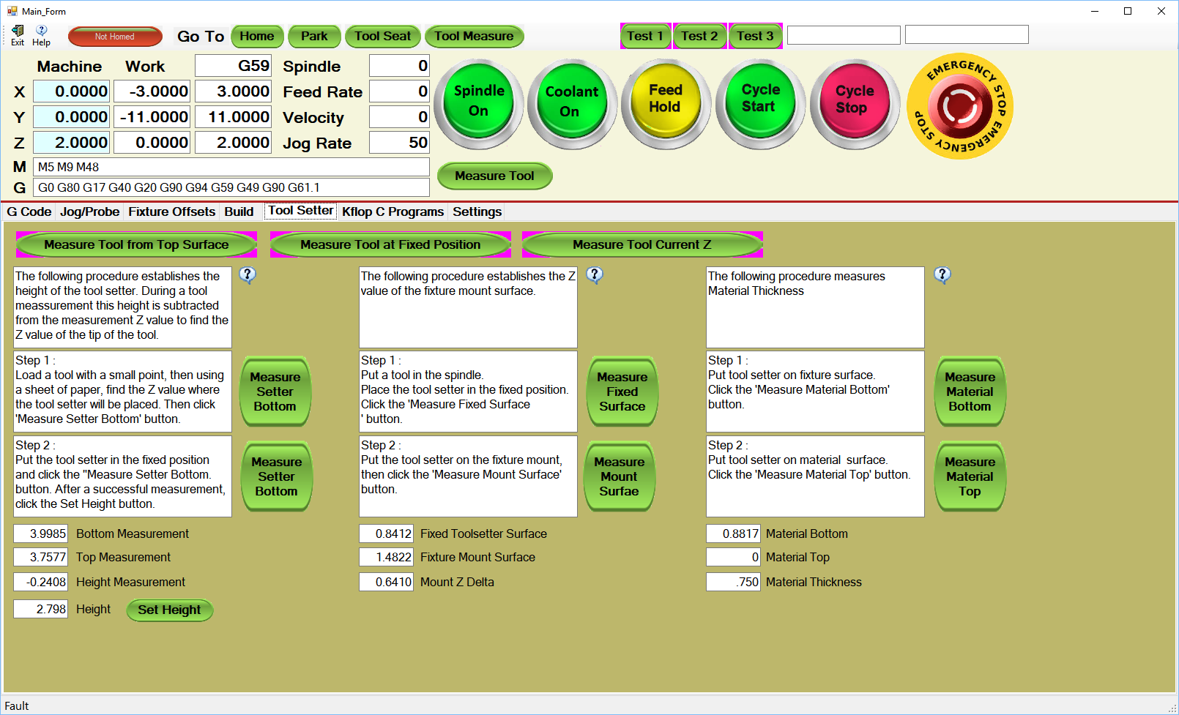

The tab is self-explanatory, listing the steps for the various measurements. The buttons cause automatic cycles that take the measurements.